1.0 PURPOSE

- To outline a system for provision of resources including human resources, to identify competencies / skill / training needs and impart the required training on continued basis ensuring employee motivation and empowerment, to NIHVA employees
- To outline a system for the planning and control of manufacturing facilities and processes that directly affect quality

2.0 SCOPE

Employees, processes and services of NIHVA

3.0 DETAILS

3.1 Provision of resources: -

- NIHVA Technologies is committed to providing adequate resources required for the establishment, implementation, maintenance and continual improvement of our QMS. Our committed resources include: competent employees, state of the industry equipment, well maintained work environment and financial resources.
- The process for determining and communicating resource requirements is an integral part of our management review process. Our infrastructure resource considerations include:
  - management review meeting inputs and outputs
  - capabilities and constraints on existing internal and external resources
  - Requirements and expectations provided by our external providers/vendors/ partners

3.2 People:

NIHVA Technologies identifies personnel training needs, provides required training, and evaluates the effectiveness of the training provided. Personnel assigned to perform specific tasks, operations and processes are qualified on the basis of appropriate education, experience or training. Employees are made aware of the relevance and importance of their activities and how they contribute to the achievement of quality objectives. Records of personnel qualifications and training are maintained

3.3 Infrastructure: -

- NIHVA Technologies has determined and provided resources necessary for the establishment, implementation, maintenance and continual improvement of the QMS. Our infrastructure resource considerations include:
  - buildings, workspace and associate duties;
  - equipment including (hardware and software);
  - transportation resources;
  - Information and communication technology.
- If any new infrastructure requirements are identified, then will be documented in quality system and other documents as required.

3.4 Environment for the operation of processes: -

(Not relevant to current product processes)

3.5 Monitoring and measuring resources

NIHVA Technologies has determined the necessary monitoring, measurement and resources to be initiated across our QMS. The structure of internal resources includes but is not limited to:
- competent & proven supply chain and partners;
- documented procedures and forms;
- Competent personnel.

Measurement Traceability -

(Not Applicable)

Documented procedures outline the processes of installation and commissioning by monitoring to accept products service operations. The procedures also include controls prior to, and after delivery of products to our customers. Appropriate documented information is maintained and provides objective evidence of compliance and conformity.

3.6 Organizational Knowledge

NIHVA Technologies considers the specific knowledge as necessary to operation and considers this as an important resource to ensure our people and processes are consistent and will achieve conformity of the product and services provided by the Company. Specific organizational knowledge is defined, maintained and available to the extent necessary within appropriate procedures.

3.7 Competence

NIHVA Technologies has determined to the extent necessary the below elements of competence for people performing work that may affect the effectiveness of the QMS.
- Ensure employees are competent on the basis of their education, training and experience;
- Measure job performance for each employee on an annual basis;
- Provide job and career training programs to the extent necessary;
- Take actions when necessary to assist employees that exhibit less than desirable results.

3.8 Awareness

NIHVA Technologies has determined to the extent necessary persons performing work are:
- Aware of the Quality Policy;
- Aware of relevant quality objectives;
- Implications of noncompliance to our QMS requirements.

3.9 Communication

NIHVA Technologies management has determined internal and external communication relevant to QMS, including the subject of the communication, when communication occurs, participant and ways of effective communication.

3.10 Documented information

- The Quality Management System Manual (APEX Manual) has been accorded the prime importance, to be followed by processes and procedures. Instructions, activities and record follow subsequently.
- QMS manual describes the overall quality management system of NIHVA which is designed to the ISO-9001:2015 requirements. This manual is released and approved by M.R. Issue control and revision control is with M.R.
- NIHVA Technologies maintains a documented QMS as a means to ensure that products and services conform to specified requirements. The QMS consists of the following three levels of documented information:
- Level 1 Quality Manual: provides the scope of the QMS and the applicable ISO 9001:2015 Clauses contained and supported by our QMS.
- Level 2 Quality System Procedures (QSP): provides detailed requirements for each of our processes with the intent to specify who does what, when, where, how the process or action/task is performed, and what documentation is used to verify that all required quality related activities had been executed as required
- Level 3 – Work instructions, quality plans etc. (documents which answers ‘How’)
- Level 4 - Quality System Forms (QSF): provides objective evidence that required product or service quality and customer requirements were achieved, and that the company's quality management system has been implemented as stated. QSF refers to tags, labels, stickers, preprinted sheets, stamps, and other means to identify the status of materials, products, equipment, gauges, and other devices used in the company to achieve the specified requirements.

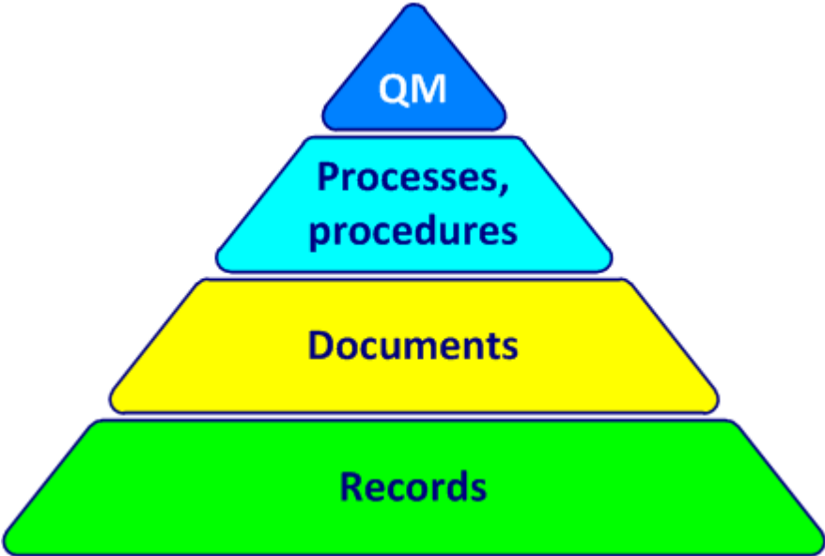

LEVEL 1: -Defines approach and responsibility

LEVEL 2: - Defines WHO, WHAT, WHEN

LEVEL 3: - Answers HOW (instruction, activities)

LEVEL 4: - Prompts recording of information e.g. forms, tags, labels, checklist etc. Once recorded, the item may become a QMS record.

3.11 Creating and Updating

When creating and updating documented information NIHVA Technologies ensures the following:
- The identification and description (revision date, approval etc.);
- The format and media (electronic, paper hard copy etc.);
- The review and approval for suitability and adequacy.

3.12 Control of Documented Information

Documented information required to support the effectiveness of our QMS is controlled to ensure:
- It is available and suitable for use, where and when it is needed;
- It is adequately protected from loss of confidentiality, improper use, or loss of integrity.
- Distribution, access, retrieval and use;
- Storage and preservation, including preservation of legibility;
- Control of changes;
- Retention and disposition.
Documented information of external origin determined to be necessary for the planning and implementation of the QMS is identified as appropriate and controlled in accordance with Quality System Procedures and Forms.

